## **TimeAndDate.com site Test Plan**

**TABLE OF CONTENTS**

**Document version —--------------------------------------------------- 1**

**Introduction —----—-------------------------------------------------- 2**

**Objectives —------—-------------------------------------------------- 2**

**Support documents —-------------------------------------------------- 2**

**Tree testing method —------------------------------------------------ 2**

**Entry and Exit Criteria —-------------------------------------------- 3**

**TEST STRATEGY —------------------------------------------------------ 4**

**Testing methodology —---------------------------------------------- 5,6**

**TEST ENVIRONMENT —--------------------------------------------------- 7**

**Milestones —--------------------------------------------------------- 8**

**ROLES & RESPONSIBILITIES —------------------------------------------- 9**

**1. Document version**

Version: 1.0

Created: 7/10/24

Last Updated: 12/10/24

**Test Plan Template**:

timeanddate

**Prepared by**:

Ayman

**Document History**

| Version | date | author | description |
| --- | --- | --- | --- |
| 1.0 | 7/10/24 | Ayman | Draft |
|  |  |  |  |
|  |  |  |  |
|  |  |  |  |
|  |  |  |  |
|  |  |  |  |
|  |  |  |  |
|  |  |  |  |
|  |  |  |  |
|  |  |  |  |
|  |  |  |  |
|  |  |  |  |

**2.INTRODUCTION**

**Purpose:** Ensure the quality, reliability, and user-friendliness of the TimeAndDate website.

**Scope:**

* Functional Testing: Verify core features.
* Non-Functional Testing: Performance assessment, security vulnerabilities, ease of use, GUI, Localization, real world scenarios

**3.Objectives**

This test plan describes the testing approach, the objectives, scope, schedule, risks, approach, Enter & Exit criteria, Test Tree and Testing methodology. and overall framework that will drive the testing.

**4. Support documents**

* SRS - Software Requirements Specification

**5. Tree Testing method**

* 1. **Functional Testing**
     1. Unit/component Testing
     2. Sanity Testing
     3. Regression Testing
     4. Integration Testing
     5. UI Testing
     6. End-to-End Testing
  2. **Non-Functional Testing**
     1. Performance Testing
     2. Security Testing
     3. Upgrade & Installation Testing
     4. Recovery Testing
     5. Localization & Globalization Testing
     6. Usability Testing
     7. GUI Testing
     8. Compatibility Testing

**6. Entry and Exit Criteria**

**6.1 Entry Criteria**

1. Windows internet browser

Any modern web browser

- Product version V 1.01.0.0

**6.2 Exit Criteria**

- 0 critical bugs

- 0 Regression bugs

- MAXIMUM 2 Medium bugs

- MAXIMUM 4 LOW bugs

**7. TEST STRATEGY**

**7.1. Test Approach**

The tests mainly prioritize the core features of the product.

**7.2. Test Automation**

Automated unit tests for the development process.

**7.3. In Scope**

**7.3.1 FUNCTIONAL TESTS FOCUS**

* Search
* Events scheduler
* UI
* User settings customizations

**7.3.2 NON-FUNCTIONAL TESTS FOCUS**

* Usability
* Localization & Globalization
* security

**7.4. Out of scope** (tests we are not going to cover)

- performance

- GUI

**8.Testing methodology**

**8.1 Validation and Defect Management**

Defects found during the Testing will be categorized according to the bug-reporting tool “Jira” and the categories are:

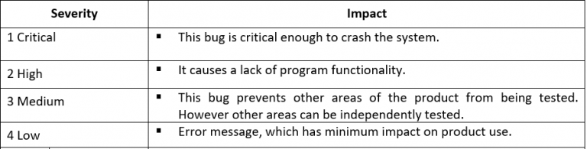

**8.2. Defect tracking & Reporting**

Flowchart depicts Defect Tracking Process

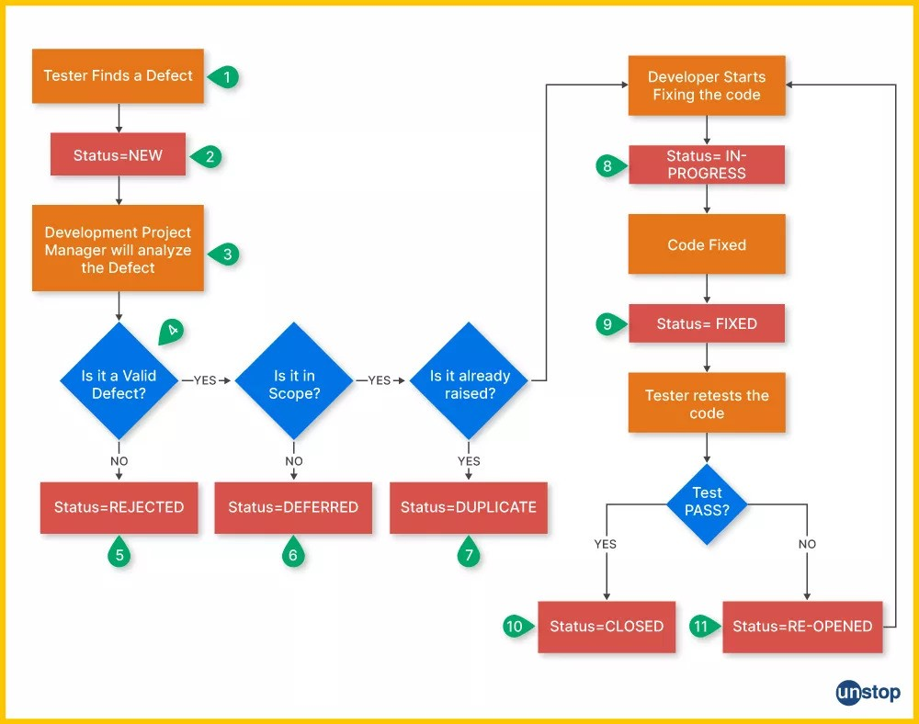

**8.3. Status of the Bug/Fault**

- New: Just created bug

- In-Progress: Opened bug and still not solved

- Rejected: rejected by Dev Lead (it's not bug)

- Deferred: the bug is expected to be fixed in next release

- Duplicate: bug that is already open

- Fixed: SOLVED bug

- Closed: bug is fixed, need to close this bug

- Re-Open: Bug was fixed and closed but appeared again with time

**8.4 TEST MANAGEMENT PROCESS**

**8.4.1 TOOLS**

|  |  |  |
| --- | --- | --- |
|  | **TOOL** | **Comments** |
| **Test Management** | Word document - (STD) | Test cases design |
| **Bug tracking** | Jira | Report bugs |
| **Agile** | Jira | Design sprint milestones |

**9. TEST ENVIRONMENT**

**9.1. HARDWARE REQUIREMENTS**

* + Windows laptop
    - Firefox
    - Google Chrome

**10.Milestones**

|  |  |  |  |
| --- | --- | --- | --- |
| **Milestone Task** | **Start date** | **End date** | **comments** |
| **STP document** | 10/07/24 | 11/07/24 | Document will be updated during the STD phase |
| **STD document** | 11/07/24 | 11/07/24 | Design Test cases/ Test Dependencies |
| **Prepare Test Environment** | 11/07/24 | 11/07/24 |  |
| **Functional testing** | 12/07/24 | 12/07/24 |  |
| **NON-Functional testing** | 13/07/24 | 13/07/24 |  |
| **Acceptance testing** | 13/07/24 | 13/07/24 | Mainly Exploratory tests |
| **STR document** | 16/07/24 | 29/07/24 | Includes bugs history and improvements |

**11. ROLES & RESPONSIBILITIES**

***QA testers:***

Ayman Khalil

***Test manager*:**

Ayman Khalil

***Test Lead*:**

Ayman Khalil